SECTION 1: Identification of the substance/mixture and of the company/undertaking

1.1. Product identifier
Product name | : | Enzymax Powder/Enzymax Pax
Product code | : | IMS-1230, IMS-1230C, IMS-1232, IMS-1233

1.2. Relevant identified uses of the substance or mixture and uses advised against
Recommended uses and restrictions | : | Concentrated Ultrasonic Detergent & Presoak

1.3. Details of the supplier of the safety data sheet
Manufactured for  Hu-Friedy Mfg. Co., LLC  3232 N. Rockwell Street | Chicago, IL 60618 | USA  1-800-Hu-Friedy or 1-773-975-6100 | Distributor  Acmedent Corp.  91 Citation Dr, Unit 5, Concord L4K 2Y8  905-761-6850  Central Dental Supply  103-251 Saulteaux Crescent, Winnipeg R3J 3C7  204-885-7530  Henry Schein Canada, Inc.  345 Townline Road, SS4, Niagara-On-The-Lake L0S 1J0  905-646-1711  K-Dental Inc.  750 Cochrane Drive, Markham L3R 8E1  416-293-8365  Patterson Dentaire Canada  1205, Boul.henri-Bourassa West, Montreal H3M 3E6  418-688-6546  Sinclair Dental Company Ltd.  900 Harbourside Drive, North Vancouver V7P 3T8  604-986-1544

1.4. Emergency telephone number
Emergency number | : | 1-800-535-5053

SECTION 2: Hazards identification

2.1. Classification of the substance or mixture

GHS classification
Skin Irrit. 2
Eye Dam. 1
Resp. Sens. 1

2.2. Label elements

GHS labelling
Hazard pictograms (GHS) | : | 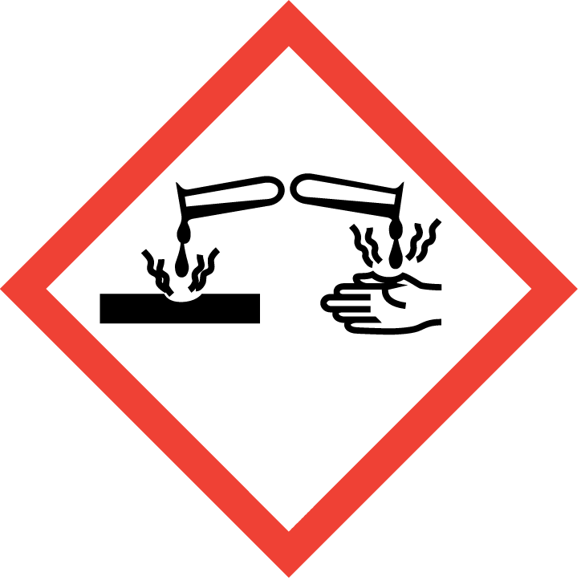  GHS05 | 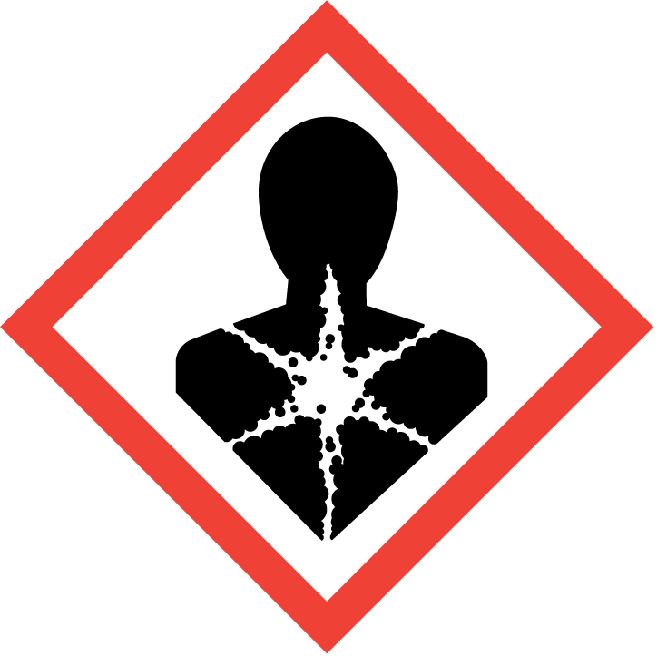  GHS08
Signal word (GHS) | : | Danger
Hazard statements (GHS) | : | Causes skin irritation. Causes serious eye damage. May cause allergy or asthma symptoms or breathing difficulties if inhaled.
Precautionary statements (GHS) | : | Avoid breathing dust/fume/gas/mist/vapours/spray. Wash hands, forearms and face thoroughly after handling. Wear protective gloves/protective clothing/eye protection/face protection. In case of inadequate ventilation wear respiratory protection. If on skin: Wash with plenty of water. Take off contaminated clothing and wash it before reuse. If skin irritation occurs: Get medical advice/attention. If inhaled: Remove person to fresh air and keep comfortable for breathing. If experiencing respiratory symptoms: Call a poison center/doctor. If in eyes: Rinse cautiously with water for several minutes. Remove contact lenses, if present and easy to do. Continue rinsing. Immediately call a poison center/doctor. Dispose of contents/container in accordance with local, regional, national and/or international regulations.

2.3. Other hazards
No additional information available

2.4. Unknown acute toxicity (GHS)
Not applicable
SECTION 3: Composition/information on ingredients

3.1. Substances
Not applicable

3.2. Mixtures

Name | Product identifier | %
Carbonic acid, sodium salt (2:3) | (CAS No) 533-96-0 | 80.82
Tetrasodium EDTA tetrahydrate | (CAS No) 13235-36-4 | 7
Sodium dodecylbenzenesulfonate | (CAS No) 25155-30-0 | 4.65
Pentasodium triphosphate | (CAS No) 7758-29-4 | 3
Sodium metasilicate | (CAS No) 6834-92-0 | 1.74
Subtilisins (proteolytic enzymes) | (CAS No) 9014-01-1 | 0.38

SECTION 4: First aid measures

4.1. Description of first aid measures
First-aid measures after inhalation | : | If breathing is difficult, remove victim to fresh air and keep at rest in a position comfortable for breathing. If experiencing respiratory symptoms: Call a POISON CENTER or doctor/physician.
First-aid measures after skin contact | : | In case of contact, immediately flush skin with plenty of water. Remove contaminated clothing and shoes. Wash clothing before reuse. Call a physician if irritation develops and persists.
First-aid measures after eye contact | : | In case of contact, immediately flush eyes with plenty of water for at least 15 minutes. If easy to do, remove contact lenses, if worn. Immediately call a poison center/doctor.
First-aid measures after ingestion | : | If swallowed, do NOT induce vomiting unless directed to do so by medical personnel. Never give anything by mouth to an unconscious person. Get medical advice/attention if you feel unwell.

4.2. Most important symptoms and effects, both acute and delayed
Symptoms/injuries after inhalation | : | May cause respiratory tract irritation. May cause allergy or asthma symptoms or breathing difficulties if inhaled.
Symptoms/injuries after skin contact | : | Causes skin irritation. Symptoms may include redness, edema, drying, defatting and cracking of the skin.
Symptoms/injuries after eye contact | : | Causes serious eye damage. Symptoms may include discomfort or pain, excess blinking and tear production, with marked redness and swelling of the conjunctiva.
Symptoms/injuries after ingestion | : | May be harmful if swallowed. May cause stomach distress, nausea or vomiting.

4.3. Indication of any immediate medical attention and special treatment needed
Symptoms may not appear immediately. In case of accident or if you feel unwell, seek medical advice immediately (show the label or SDS where possible).

SECTION 5: Firefighting measures

5.1. Extinguishing media
Suitable extinguishing media | : | Treat for surrounding material.
Unsuitable extinguishing media | : | None known.

5.2. Special hazards arising from the substance or mixture
Fire hazard | : | Products of combustion may include, and are not limited to: oxides of carbon.

5.3. Advice for firefighters
Protection during firefighting | : | Keep upwind of fire. Wear full fire fighting turn-out gear (full Bunker gear) and respiratory protection (SCBA).

SECTION 6: Accidental release measures

6.1. Personal precautions, protective equipment and emergency procedures
General measures | : | Use personal protection recommended in Section 8. Isolate the hazard area and deny entry to unnecessary and unprotected personnel.

6.2. Methods and material for containment and cleaning up
For containment | : | Dike and contain spill. Contain spill, then place in a suitable container. Minimize dust generation. Do not flush to sewer or allow to enter waterways. Use appropriate Personal Protective Equipment (PPE).
Methods for cleaning up | : | Vacuum or sweep material and place in a disposal container. Provide ventilation.

6.3. Reference to other sections
See section 8 for further information on protective clothing and equipment and section 13 for advice on waste disposal.

SECTION 7: Handling and storage

7.1. Precautions for safe handling
Precautions for safe handling | : | Avoid contact with skin and eyes. Avoid breathing dust/fume/gas/mist/vapours/spray. Do not swallow. Handle and open container with care. When using do not eat, drink or smoke. Use only in well ventilated areas.
Hygiene measures | : | Launder contaminated clothing before reuse. Wash hands before eating, drinking, or smoking.

7.2. Conditions for safe storage, including any incompatibilities
Storage conditions | : | Keep out of the reach of children. Keep container tightly closed. Store in a dry, cool and well-ventilated place.

7.3. Specific end use(s)
Not available.

SECTION 8: Exposure controls/personal protection

8.1. Control parameters
Carbonic acid, sodium salt (2:3) (533-96-0)
ACGIH | Not applicable
OSHA | Not applicable

Tetrasodium EDTA tetrahydrate (13235-36-4)
ACGIH | Not applicable
OSHA | Not applicable

Sodium dodecylbenzenesulfonate (25155-30-0)
ACGIH | Not applicable
OSHA | Not applicable

Pentasodium triphosphate (7758-29-4)
ACGIH | Not applicable
OSHA | Not applicable

Sodium metasilicate (6834-92-0)
ACGIH | Not applicable
OSHA | Not applicable

Subtilisins (proteolytic enzymes) (9014-01-1)
ACGIH | ACGIH Ceiling (mg/m³) | 0.00006 mg/m³
OSHA | Not applicable
NIOSH | NIOSH REL (STEL) (mg/m³) | 0.00006 mg/m³

8.2. Exposure controls
Appropriate engineering controls | : | Use ventilation adequate to keep exposures (airborne levels of dust, fume, vapor, etc.) below recommended exposure limits.
Hand protection | : | Wear chemically resistant protective gloves.
Eye protection | : | Wear approved eye (properly fitted dust- or splash-proof chemical safety goggles) / face (face shield) protection.
Skin and body protection | : | Wear suitable protective clothing.
Respiratory protection | : | In case of insufficient ventilation, wear suitable respiratory equipment. Respirator selection must be based on known or anticipated exposure levels, the hazards of the product and the safe working limits of the selected respirator.
Environmental exposure controls | : | Maintain levels below Community environmental protection thresholds.
Other information | : | Do not eat, smoke or drink where material is handled, processed or stored. Wash hands carefully before eating or smoking. Handle according to established industrial hygiene and safety practices.

SECTION 9: Physical and chemical properties

9.1. Information on basic physical and chemical properties
Physical state | : | Solid
Appearance | : | Powder
Colour | : | White with beige specs
Odour | : | Lemon
Odour threshold | : | No data available
pH | : | 10 (0.5 % dilution)
Melting point | : | No data available
Freezing point | : | No data available
Boiling point | : | No data available
Flash point | : | No data available
Relative evaporation rate (butylacetate=1) | : | No data available
Flammability (solid, gas) | : | Not flammable
Explosive limits | : | No data available
Explosive properties | : | No data available
Oxidising properties | : | No data available
Vapour pressure | : | No data available
Relative density | : | 0.79
Relative vapour density at 20 °C | : | No data available
Solubility | : | No data available
Partition coefficient n-octanol/water | : | No data available
Auto-ignition temperature | : | No data available
Decomposition temperature | : | No data available
Viscosity | : | No data available
Viscosity, kinematic | : | No data available
Viscosity, dynamic | : | No data available

9.2. Other information
No additional information available

SECTION 10: Stability and reactivity

10.1. Reactivity
No dangerous reaction known under conditions of normal use.

10.2. Chemical stability
Stable under normal storage conditions.

10.3. Possibility of hazardous reactions
No dangerous reaction known under conditions of normal use.

10.4. Conditions to avoid
Heat. Incompatible materials.

10.5. Incompatible materials
Oxidizing agents.

10.6. Hazardous decomposition products
May include, and are not limited to: oxides of carbon.

SECTION 11: Toxicological information

11.1. Information on toxicological effects

Acute toxicity | : | Not classified.

Enzymax Powder/Enzymax Pax
LD50 oral rat | > 2000 mg/kg (Calculated Acute Toxicity Estimate)
LD50 dermal rabbit | > 2000 mg/kg (Calculated Acute Toxicity Estimate)
LC50 inhalation rat | > 5 mg/m³/4h (Calculated Acute Toxicity Estimate)

Sodium dodecylbenzenesulfonate (25155-30-0)
LD50 oral rat | 500 mg/kg

Pentasodium triphosphate (7758-29-4)
LD50 oral rat | 3120 mg/kg
LD50 dermal rabbit | > 7940 mg/kg

Sodium metasilicate (6834-92-0)
LD50 oral rat | 1153 mg/kg

Subtilisins (proteolytic enzymes) (9014-01-1)
LD50 oral rat | 3700 mg/kg

Skin corrosion/irritation | : | Causes skin irritation.
Serious eye damage/irritation | : | Causes serious eye damage.
Respiratory or skin sensitisation | : | May cause allergy or asthma symptoms or breathing difficulties if inhaled.
Germ cell mutagenicity | : | Based on available data, the classification criteria are not met
Carcinogenicity | : | Based on available data, the classification criteria are not met
Reproductive toxicity | : | Based on available data, the classification criteria are not met
Specific target organ toxicity (single exposure) | : | Based on available data, the classification criteria are not met
Specific target organ toxicity (repeated exposure) | : | Based on available data, the classification criteria are not met
Aspiration hazard | : | Based on available data, the classification criteria are not met
Symptoms/injuries after inhalation | : | May cause respiratory tract irritation. May cause allergy or asthma symptoms or breathing difficulties if inhaled.
Symptoms/injuries after skin contact | : | Causes skin irritation. Symptoms may include redness, edema, drying, defatting and cracking of the skin.
Symptoms/injuries after eye contact | : | Causes serious eye damage. Symptoms may include discomfort or pain, excess blinking and tear production, with marked redness and swelling of the conjunctiva.
Symptoms/injuries after ingestion | : | May be harmful if swallowed. May cause stomach distress, nausea or vomiting.

SECTION 12: Ecological information

12.1. Toxicity
Ecology - general | : | May cause long-term adverse effects in the aquatic environment.

12.2. Persistence and degradability
Enzymax Powder/Enzymax Pax
Persistence and degradability | Not established.

12.3. Bioaccumulative potential
Enzymax Powder/Enzymax Pax
Bioaccumulative potential | Not established.

12.4. Mobility in soil
No additional information available

12.5. Other adverse effects
Effect on global warming | : | No known effects from this product.

SECTION 13: Disposal considerations

13.1. Waste treatment methods
Waste disposal recommendations | : | This material must be disposed of in accordance with all local, state, provincial, and federal regulations. The generation of waste should be avoided or minimized wherever possible.

SECTION 14: Transport information

Department of Transportation (DOT) and Transportation of Dangerous Goods (TDG)
In accordance with DOT and TDG
Not regulated for transport

Additional information
Other information | : | No supplementary information available.

Special transport precautions | : | Do not handle until all safety precautions have been read and understood.

SECTION 15: Regulatory information

15.1. US Federal regulations
All components of this product are listed, or excluded from listing, on the United States Environmental Protection Agency Toxic Substances Control Act (TSCA) inventory.

All components of this product are listed, or excluded from listing, on the Canadian DSL (Domestic Substances List) and NDSL (Non-Domestic Substances List) inventories.

15.2. US State regulations

Enzymax Powder/Enzymax Pax
State or local regulations | This product does not contain a chemical known to the State of California to cause cancer, birth defects or other reproductive harm

SECTION 16: Other information

Date of issue | : | 10/03/2016
Revision date | : | 10/03/2016
Other information | : | None.

Disclaimer: We believe the statements, technical information and recommendations contained herein are reliable, but they are given without warranty or guarantee of any kind. The information contained in this document applies to this specific material as supplied. It may not be valid for this material if it is used in combination with any other materials. It is the user’s responsibility to satisfy oneself as to the suitability and completeness of this information for the user’s own particular use.

